ML Unit 3

1*) What do you mean by coefficient of regression? Explain SSE, MSE and MAE in context of regression.*

Ans. **Coefficient of Regression**

The coefficient of regression, also known as the regression coefficient, is a numerical value that represents the relationship between a dependent variable (target) and one or more independent variables (predictors) in regression analysis. It indicates the strength and direction of the relationship.

* In **simple linear regression**, the coefficient of regression (β1\beta_1) is the slope of the line that best fits the data.
  + **Positive coefficient**: As the independent variable increases, the dependent variable also increases.
  + **Negative coefficient**: As the independent variable increases, the dependent variable decreases.

In a mathematical sense, the coefficient represents the change in the dependent variable for a one-unit change in the independent variable, keeping other variables constant (if applicable).

**SSE, MSE, and MAE in Context of Regression**

These are error metrics used to evaluate the performance of regression models by comparing predicted values with actual values.

**1. SSE (Sum of Squared Errors)**

* **Explanation**:
  + Measures the total squared differences between the actual (yi) and predicted (y^i\hat{y}_i) values.
  + It penalizes large errors more than small errors due to squaring.
  + Lower SSE indicates better model performance.

**2. MSE (Mean Squared Error)**

* **Explanation**:
  + MSE is the average of the squared errors.
  + It normalizes the SSE by dividing by the total number of data points (nn).
  + Like SSE, it is sensitive to large errors.
  + MSE is commonly used because it provides a clearer scale for evaluating errors.

**3. MAE (Mean Absolute Error)**

* **Explanation**:
  + Measures the average absolute difference between actual and predicted values.
  + Unlike MSE, it does not square the errors, so it treats all errors linearly.
  + MAE is less sensitive to large outliers compared to SSE or MSE.

**Comparison of Metrics**

* **SSE** is used when analyzing total error but is not normalized for the number of data points.
* **MSE** is preferred for its mathematical properties, especially in optimization (e.g., gradient descent).
* **MAE** is more interpretable and robust to outliers.

In practical scenarios, the choice of metric depends on the specific problem and the importance of handling large errors differently.

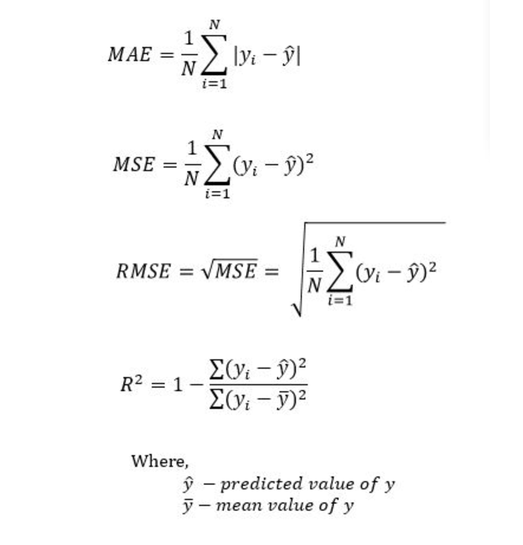



2*) What is multiple regression? How it is different from simple linear regression*

Ans. **Multiple Regression**

**Multiple regression** is a statistical technique used to model the relationship between a dependent variable (target) and two or more independent variables (predictors). It is an extension of simple linear regression, which uses only one predictor.

* **Equation**:  
  y=β0+β1x1+β2x2+⋯+βkxk+ϵy = \beta_0 + \beta_1x_1 + \beta_2x_2 + \dots + \beta_kx_k + \epsilon  
  Where:
  + yy: Dependent variable (target)
  + β0\beta_0: Intercept (value of yy when all xix_i's are 0)
  + β1,β2,…,βk\beta_1, \beta_2, \dots, \beta_k: Regression coefficients (representing the effect of each independent variable xix_i on yy)
  + x1,x2,…,xkx_1, x_2, \dots, x_k: Independent variables
  + ϵ\epsilon: Error term (accounts for variation not explained by predictors)

**Simple Linear Regression**

**Simple linear regression** models the relationship between one dependent variable and a single independent variable.

* **Equation**:  
  y=β0+β1x+ϵy = \beta_0 + \beta_1x + \epsilon  
  Where:
  + yy: Dependent variable
  + xx: Independent variable
  + β0\beta_0: Intercept
  + β1\beta_1: Slope (change in yy for a one-unit change in xx)
  + ϵ\epsilon: Error term

**Key Differences Between Multiple and Simple Linear Regression**

| **Aspect** | **Simple Linear Regression** | **Multiple Regression** |
| --- | --- | --- |
| **Number of Predictors** | One independent variable (xx) | Two or more independent variables (x1,x2,…x_1, x_2, \dots) |
| **Equation** | y=β0+β1x+ϵy = \beta_0 + \beta_1x + \epsilon | y=β0+β1x1+β2x2+⋯+ϵy = \beta_0 + \beta_1x_1 + \beta_2x_2 + \dots + \epsilon |
| **Complexity** | Simple and easy to visualize (2D graph) | More complex; visualization not straightforward for >2 variables |
| **Use Case** | Understand the effect of a single predictor | Analyze and predict based on multiple factors |
| **Interpretability** | Coefficients are easier to interpret | Coefficients need to account for interaction between predictors |
| **Overfitting Risk** | Lower risk | Higher risk, especially with many predictors and limited data |
| **Interactions** | Ignores interactions between predictors | Can model and analyze interaction effects |

**Example:**

1. **Simple Linear Regression**:
   * Predict house price (yy) based on square footage (xx).
   * y=β0+β1⋅Square Footage+ϵy = \beta_0 + \beta_1 \cdot \text{Square Footage} + \epsilon
2. **Multiple Regression**:
   * Predict house price (yy) based on square footage (x1x_1) and number of bedrooms (x2x_2).
   * y=β0+β1⋅Square Footage+β2⋅Bedrooms+ϵy = \beta_0 + \beta_1 \cdot \text{Square Footage} + \beta_2 \cdot \text{Bedrooms} + \epsilon

Multiple regression is more versatile but requires careful handling to avoid overfitting and multicollinearity among predictors.



3) *Explain under fit, over fit and just fit models for Regression*

Ans. **Underfit, Overfit, and Just Fit Models in Regression**

In the context of regression, these terms describe how well the model generalizes to unseen data:

**1. Underfit Model**

An **underfit model** occurs when the model is too simple to capture the underlying patterns in the data. It performs poorly on both the training and test data because it fails to learn the relationships between the independent variables (predictors) and the dependent variable (target).

* **Causes**:
  + Using a linear model for a highly nonlinear relationship.
  + Inadequate number of features or ignoring important predictors.
  + Insufficient training or overly simple algorithms.
* **Characteristics**:
  + High **bias** (systematic error).
  + Low variance (consistent predictions but far from the true values).
  + Poor performance on training and test datasets.
* **Example**:
  + A straight-line model applied to data with a quadratic relationship.

**2. Overfit Model**

An **overfit model** occurs when the model is too complex and captures not only the underlying patterns in the data but also the noise or random fluctuations. It performs well on the training data but poorly on test data because it lacks generalization.

* **Causes**:
  + Using too many features or overly complex models (e.g., high-degree polynomial regression).
  + Insufficient data relative to the complexity of the model.
  + Failure to use regularization techniques.
* **Characteristics**:
  + Low bias (accurate predictions

on training data).

* High **variance** (predictions vary significantly on test data).
* Excellent performance on training data but poor performance on test datasets.
* **Example**:
  + A high-degree polynomial curve that perfectly fits the training data points but fluctuates wildly for new inputs.

**3. Just Fit Model**

A **just fit model** strikes a balance between underfitting and overfitting. It captures the essential patterns in the data without modeling the noise, achieving good performance on both training and test datasets.

* **Causes**:
  + Proper feature selection and engineering.
  + Choosing an appropriate model complexity.
  + Sufficient data for training.
  + Using regularization techniques to prevent overfitting.
* **Characteristics**:
  + Moderate bias (does not oversimplify the data relationships).
  + Moderate variance (performs consistently across datasets).
  + Good performance on both training and test datasets.
* **Example**:
  + A regression model that captures the true relationship (e.g., linear regression for a linear dataset or polynomial regression for quadratic data).

**Visual Representation (Conceptual):**

* **Underfit**: A straight line through scattered points (misses patterns).
* **Overfit**: A wavy curve that passes through every point (fits noise).
* **Just Fit**: A smooth curve that captures the general trend (fits the true pattern).

**Strategies to Avoid Underfitting and Overfitting:**

* **To Address Underfitting**:
  + Increase model complexity (e.g., add features, use higher-degree polynomials).
  + Use more sophisticated algorithms.
  + Improve feature engineering.
* **To Address Overfitting**:
  + Reduce model complexity (simpler models or fewer features).
  + Use regularization techniques (e.g., L1/Lasso or L2/Ridge regularization).
  + Increase the size of the dataset.
  + Use cross-validation to tune hyperparameters.



4) *Explain bias-variance dilemma*

Ans. 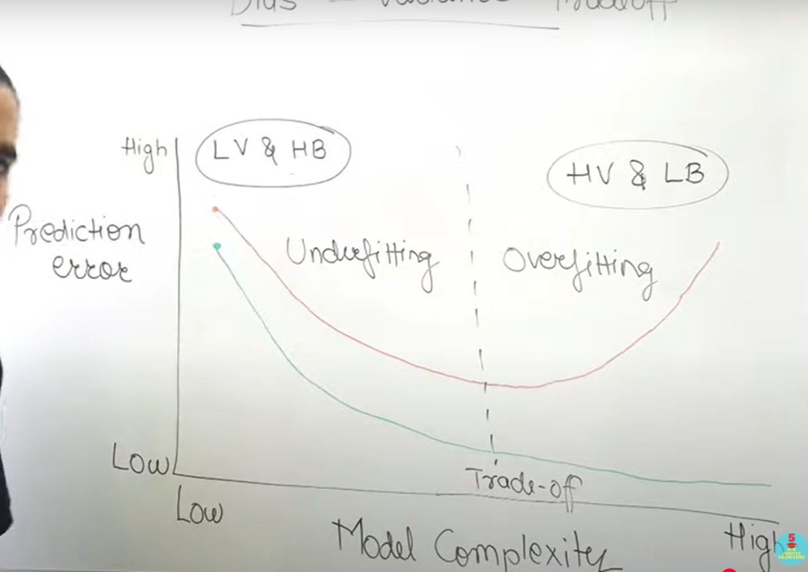

**Bias-Variance Dilemma**

The **bias-variance dilemma** is a fundamental trade-off in machine learning and statistical modeling. It describes the challenge of balancing two sources of error to achieve good model performance on unseen data:

1. **Bias**: Error due to overly simplistic assumptions in the model.
2. **Variance**: Error due to the model's sensitivity to small fluctuations in the training data.

The goal is to minimize both bias and variance, but reducing one often increases the other.

**Key Concepts**

**1. Bias**

* **Definition**: Bias refers to the error introduced by approximating a real-world problem (which may be complex) with a simple model.
* **Characteristics**:
  + High bias occurs when the model is too simple (e.g., underfitting).
  + The model fails to capture the underlying patterns in the data.
  + Predictions are consistently wrong or far from actual values.
* **Example**: Using a linear model to fit data with a quadratic relationship.

**2. Variance**

* **Definition**: Variance refers to the error introduced due to the model’s sensitivity to small variations in the training data.
* **Characteristics**:
  + High variance occurs when the model is too complex (e.g., overfitting).
  + The model captures noise and fluctuations in the training data, leading to poor generalization.
  + Predictions vary significantly for different training datasets.
* **Example**: Using a high-degree polynomial to fit a dataset with noise.

**The Trade-Off**

* **High Bias, Low Variance**:
  + The model is too simple.
  + Fails to capture patterns (underfitting).
  + Consistently wrong but predictions are stable.
* **Low Bias, High Variance**:
  + The model is too complex.
  + Captures patterns and noise (overfitting).
  + Predictions vary significantly on new data.
* **Optimal Balance**:
  + A model with moderate bias and moderate variance achieves good performance.
  + It captures the underlying patterns without overreacting to noise.

**Visualization**

1. **High Bias**: The model is far from the target (systematic error).
2. **High Variance**: The model fluctuates around the target (random error).
3. **Balanced Model**: The model is close to the target and consistent.

**Strategies to Address the Bias-Variance Trade-Off**

1. **Reduce Bias**:
   * Increase model complexity (e.g., add features, use a more flexible algorithm).
   * Train longer or provide more data to the model.
2. **Reduce Variance**:
   * Simplify the model (e.g., use fewer features or a simpler algorithm).
   * Use regularization techniques (e.g., L1/Lasso or L2/Ridge).
   * Increase the size of the training data.
   * Use techniques like cross-validation to reduce overfitting.

**Conclusion**

The bias-variance dilemma emphasizes the need to balance simplicity and complexity in model selection and training. A well-tuned model minimizes both bias and variance, leading to better generalization on unseen data.



5) *What is univariate and multivariate regression? Explain any three measures of Evaluation of performance of regression model.*

Ans. **Univariate and Multivariate Regression**

**1. Univariate Regression**

* **Definition**: In univariate regression, there is only one independent variable (predictor) used to predict a single dependent variable (target).
* **Example**: Predicting a house price (yy) based solely on its square footage (xx).
* **Equation**:  
  y=β0+β1x+ϵy = \beta_0 + \beta_1x + \epsilon

**2. Multivariate Regression**

* **Definition**: In multivariate regression, multiple independent variables (predictors) are used to predict a single dependent variable (target).
* **Example**: Predicting a house price (yy) based on square footage (x1x_1) and number of bedrooms (x2x_2).
* **Equation**:  
  y=β0+β1x1+β2x2+⋯+βkxk+ϵy = \beta_0 + \beta_1x_1 + \beta_2x_2 + \dots + \beta_kx_k + \epsilon

**Key Differences:**

| **Aspect** | **Univariate Regression** | **Multivariate Regression** |
| --- | --- | --- |
| **Number of Predictors** | One | Two or more |
| **Complexity** | Simpler to analyze and visualize | More complex, harder to visualize |
| **Use Case** | Basic relationships | Complex relationships with multiple factors |

**Measures of Evaluation of Regression Model Performance**

To evaluate how well a regression model performs, the following metrics are commonly used:

**1. Mean Absolute Error (MAE)**

* **Formula**:  
  MAE=1n∑i=1n∣yi−y^i∣\text{MAE} = \frac{1}{n} \sum_{i=1}^{n} |y_i - \hat{y}_i|
* **Explanation**:
  + Measures the average absolute difference between actual (yiy_i) and predicted (y^i\hat{y}_i) values.
  + Less sensitive to outliers compared to squared-error metrics.
* **Interpretation**:
  + Lower MAE indicates better model performance.

**2. Mean Squared Error (MSE)**

* **Formula**:  
  MSE=1n∑i=1n(yi−y^i)2\text{MSE} = \frac{1}{n} \sum_{i=1}^{n} (y_i - \hat{y}_i)^2
* **Explanation**:
  + Measures the average squared differences between actual and predicted values.
  + Penalizes larger errors more heavily than MAE due to squaring.
* **Interpretation**:
  + Lower MSE indicates better model performance. However, it may overemphasize large errors.

**3. R-Squared (R2R^2)**

* **Formula**:  
  R2=1−SSESSTR^2 = 1 - \frac{\text{SSE}}{\text{SST}}, where:
  + SSE=∑i=1n(yi−y^i)2\text{SSE} = \sum_{i=1}^{n} (y_i - \hat{y}_i)^2 (Sum of Squared Errors)
  + SST=∑i=1n(yi−yˉ)2\text{SST} = \sum_{i=1}^{n} (y_i - \bar{y})^2 (Total Sum of Squares)
* **Explanation**:
  + Measures the proportion of variance in the dependent variable that is explained by the model.
  + R2R^2 ranges from 0 to 1, where:
    - R2=1R^2 = 1: Perfect fit.
    - R2=0R^2 = 0: Model does not explain the variance.
* **Interpretation**:
  + Higher R2R^2 indicates better fit, but it does not account for overfitting.

**Summary of Evaluation Metrics:**

| **Metric** | **Use** | **Sensitivity** |
| --- | --- | --- |
| **MAE** | Robust to outliers, easy to interpret | Low sensitivity to outliers |
| **MSE** | Penalizes larger errors heavily | High sensitivity to outliers |
| **R-Squared** | Explains variance but may not detect overfitting | Indicates goodness of fit |

By combining these metrics, we can comprehensively evaluate the performance and generalization ability of a regression model.



6)

Ans.